BANKING SYSTEM

Create Database banking:

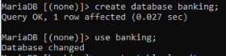

Create table account,customer,depositor,loan,borrower,branch:



C:\Users\Swetha\Desktop\Dbms\5.db13.PNG

C:\Users\Swetha\Desktop\Dbms\5.db11.PNG

C:\Users\Swetha\Desktop\Dbms\5.db10.PNG



C:\Users\Swetha\Desktop\Dbms\5.db8.PNG

Insert datas into the table account,customer,depositor,loan,borrower,branch:

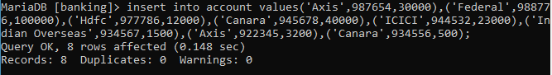

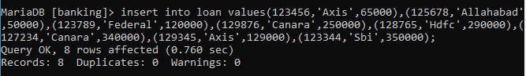

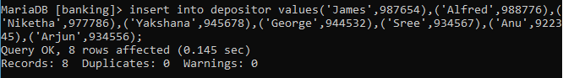

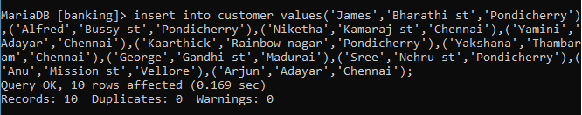

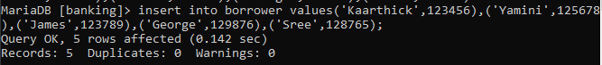

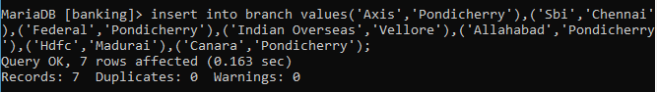

Display the datas from the table account,customer,depositor,loan,borrower,branch:

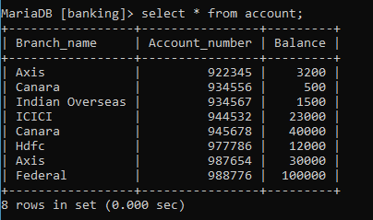

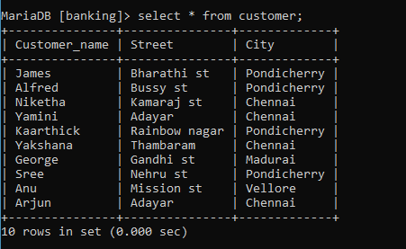

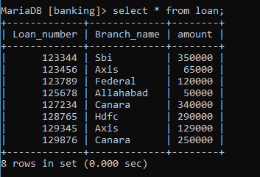

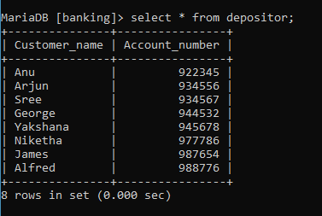

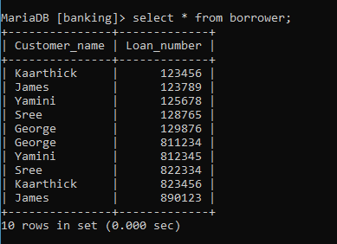

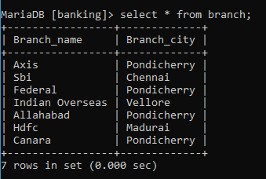

1. Find all customers who have an account but no loan:

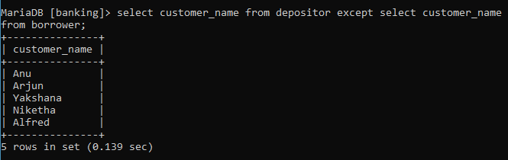

2. List the names of all customers having a loan in Axis: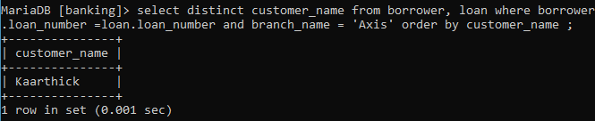

3.Find the count of customers having account or loan in the bank:

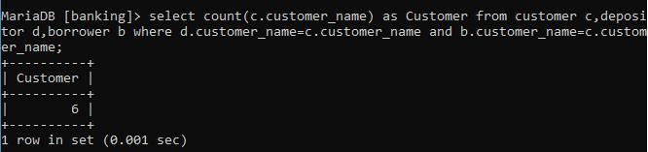

4.Find the names of all customers who have an account at all branches located at Madurai:

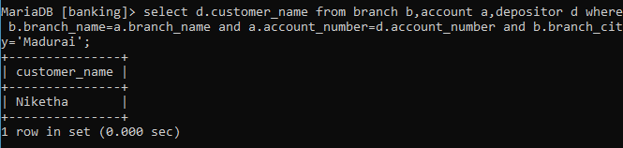

5.Find the names of all customers having loan in the Canara bank and in the cities in which they live:

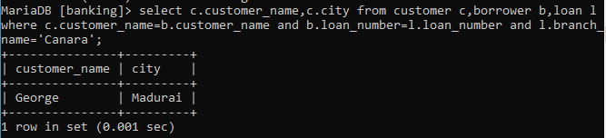

6.Find the number of depositors for each branch:

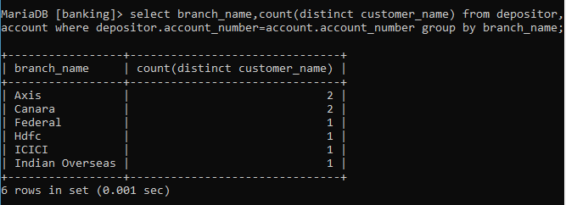

7. Display the bank that has maximum average balance:

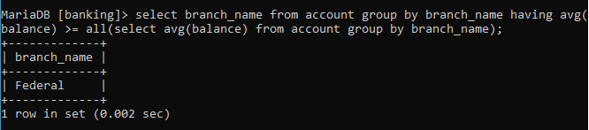

8. Display the customers who have balance greater than 15000

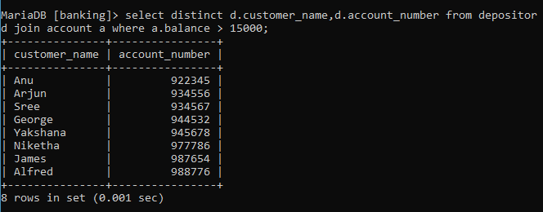

9. Display the account number with maximum balance:

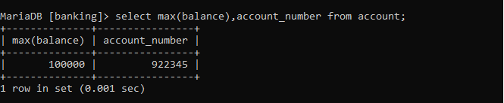

10. Display the customer name who have both account and have borrowed loan from the bank:

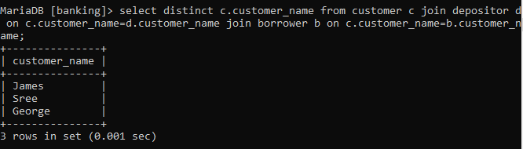

11. Display the customer who have hired loan in canara bank:

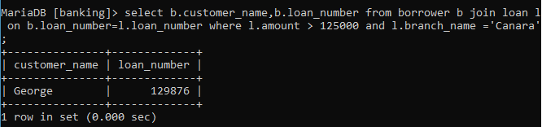

12. Display the customer name and loan number who have loan amount greater than 125000.

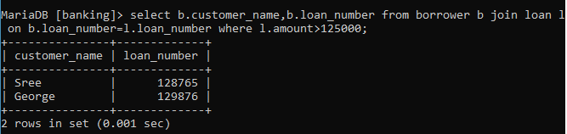

13. Display only the customers names who have an account in the bank:

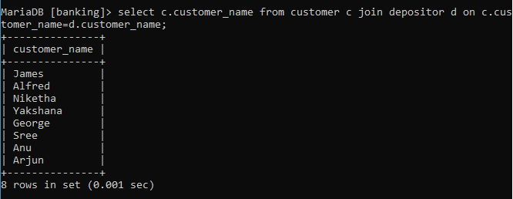

14. Display the customers names who have applied for loan and the customer city is Pondicherry: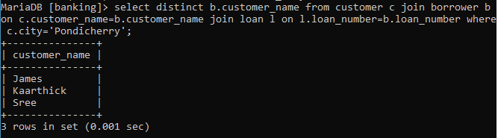

15. Display all the customer names who have only loan in the bank:

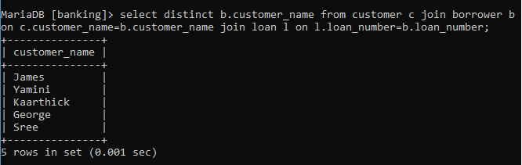

16. Display the customer name and branch for those who have an account in the axis branch

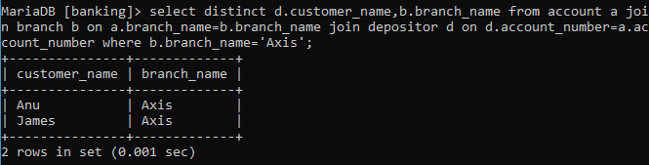

17. Display the customer name who has borrowed loan from the Axis Bank

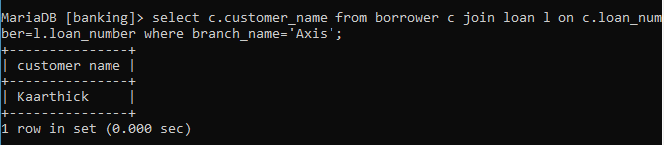

18.Display Loan number,branch name and amount from loan where amount is greater than 100000:

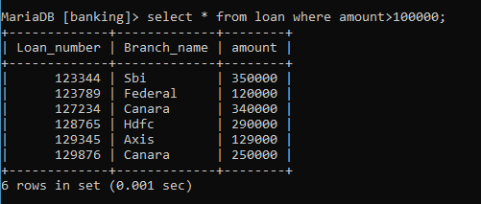

19.Display all the customer names who has either borrowed or deposited in the bank:

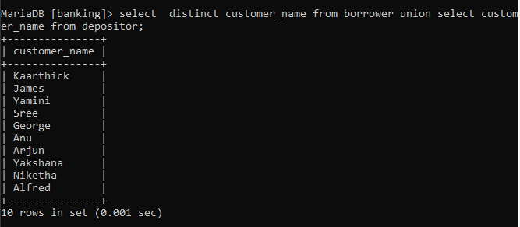

20.Find the average account balance at Canara:

